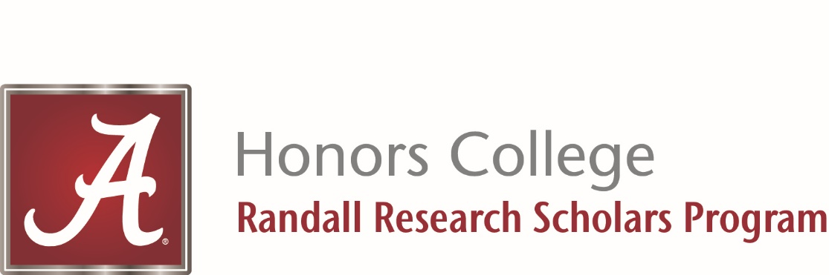

The Randall Research Scholars Program
Invites You To Join Us For
RRS LIVE 2020
RRS LIVE is a live interactive broadcast of research projects conducted by students in the Randall Research Scholars Program. Students will discuss the goals, outcomes and societal impact of the research they have conducted during the Fall 2020 semester.

The Catherine J. Randall Research Scholars Program is a nationally recognized interdisciplinary undergraduate research program which pairs academically elite students directly with leading research professors and cutting-edge computing technology to complete scholarly research projects in any field of study.

Presentations will broadcast:
Wednesday, December 2 – 4:00 PM to 9:00 PM
Thursday, December 3 - 4:00 PM to 9:00 PM
Friday, December 4 – 3:00 PM to 8:00 PM
For a Complete List of Presentations and to Watch RRS LIVE
Go To

https://live.rrsp.ua.edu/

For More Information on the Randall Research Scholars Program
https://honors.ua.edu/programs/randall-research-scholars-program/

RRSP Priority Application Deadline is December 13, 2020

